Beautiful & Fragrant Candles
Josephine McDermott Circle

100% of profits benefits ACC – Advocacy and Caring for Children
Your purchase helps support families and children in need.
$25/candle

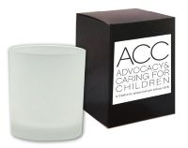
Candle Details
10 oz.white glass with black lid to preserve scent
Lovely ginger and citrus scent
Burns 55 hours
Comes in a black box

They make beautiful gifts for every occasion:
Holidays
Birthdays
Get Well Wishes
Congratulations
Graduation
Hostess Gifts
Mother’s Day

Accepting orders through October 31. Place your order HERE. You can pay two ways:
- Venmo: @Wendy-Bambrick
- Pay upon pick-up.

Pick Up Details
Free delivery in Seattle area for orders of 10 or more!

Where
St. Bridget Catholic Church
4900 NE 50th Street – Seattle
When
December 1 or December 2
10:00 am to Noon

Questions?
Sheryl Welch slowelch@comcast.net

